**Coal lab 02**

Name: Syed Muzzamil Waseem

SID: 11067

Question 1

CODE:

INCLUDE Irvine32.inc

.data

;Syed Muzzamil Waseem 11067

.code

main PROC

mov eax,22

mov ebx,5

sub edx,edx

div ebx

call WriteDec

call crlf

mov eax,edx

call WriteDec

call crlf

exit

main ENDP

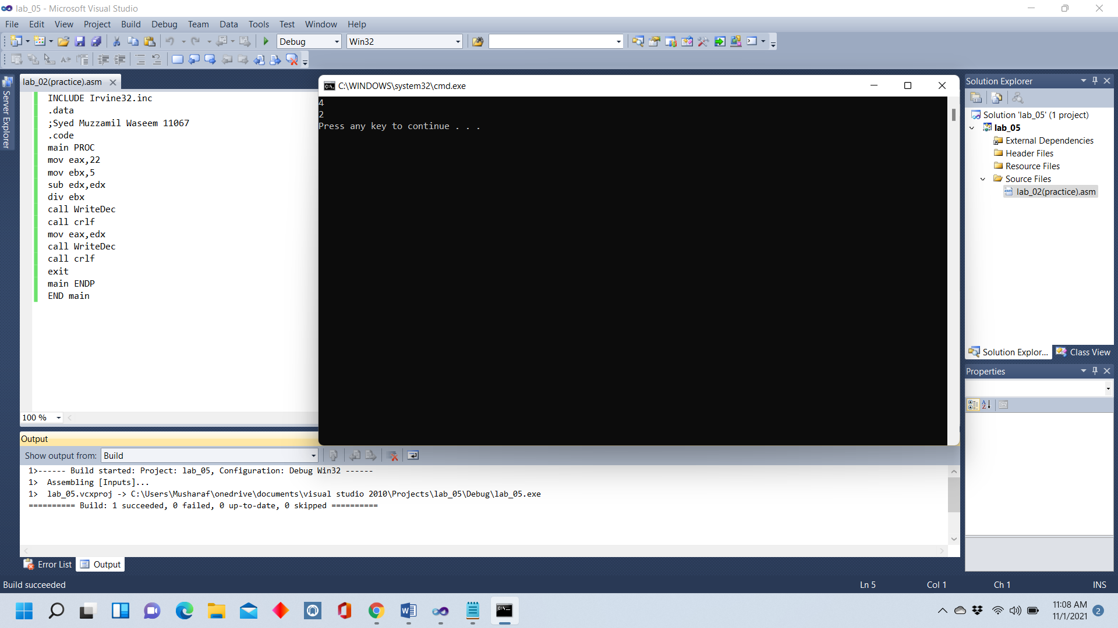END main

Question 2(a)

CODE:

INCLUDE Irvine32.inc

.data

;Syed Muzzamil Waseem 11067

.code

main PROC

mov eax,5

add eax,2

call WriteDec

call crlf

mov eax,6

sub eax,4

call WriteDec

call crlf

mov eax,7

mov ebx,2

mul ebx

call WriteDec

call crlf

exit

main ENDP

END main

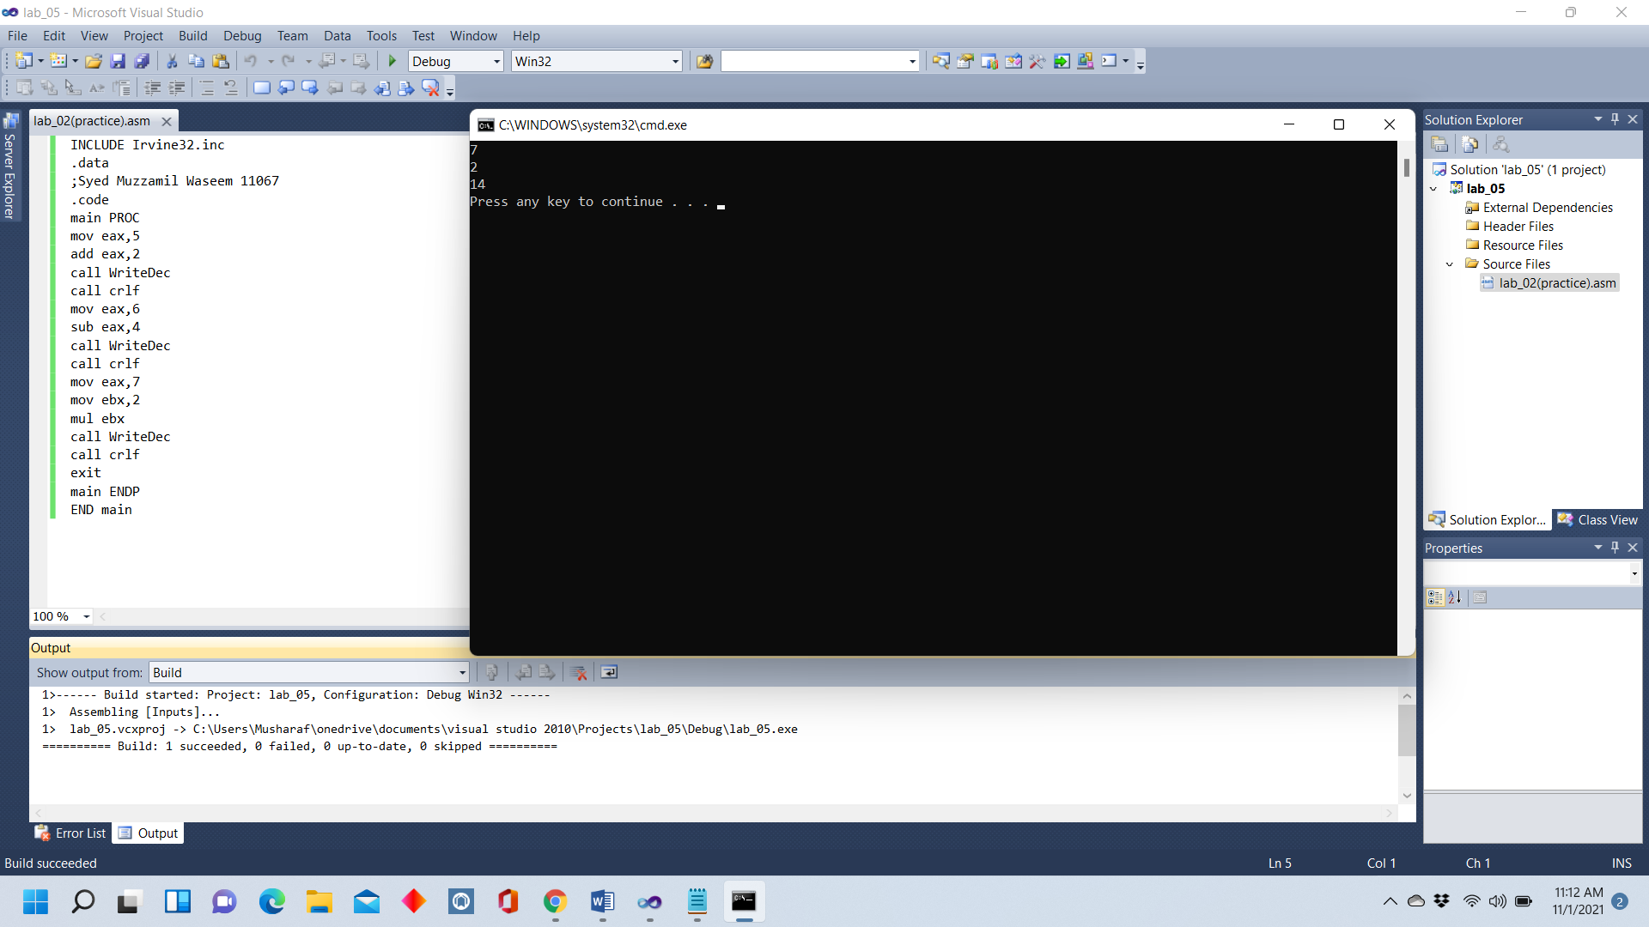

Question 2(b)

CODE:

INCLUDE Irvine32.inc

.data

;Syed Muzzamil Waseem 11067

.code

main PROC

mov eax,7

mov ebx,8

mul ebx

call WriteDec

call crlf

mov eax,3

mov ebx,2

mul ebx

call WriteDec

call crlf

mov eax,56

mov ebx,6

sub eax,ebx

call WriteDec

call crlf

exit

main ENDP

END main

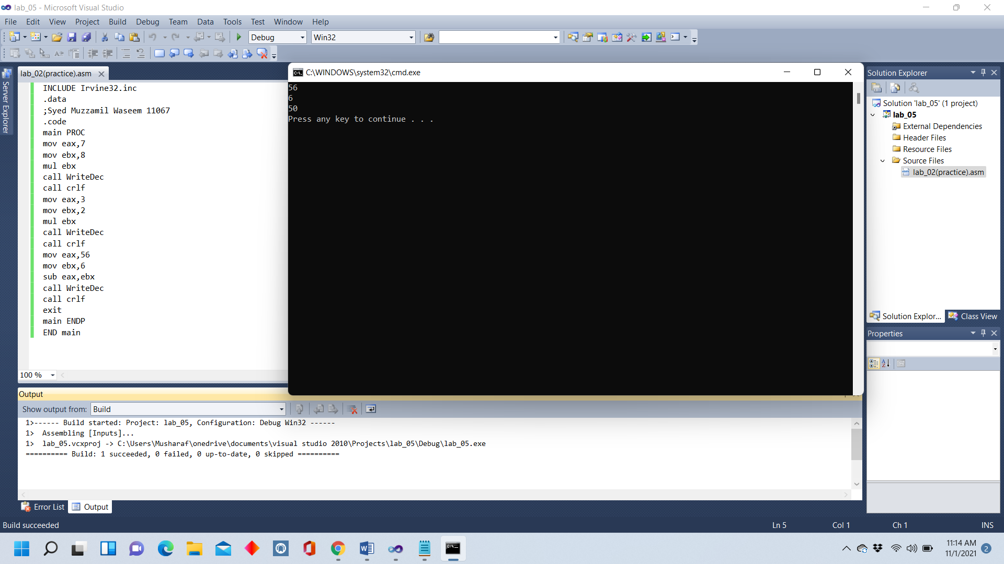

Question 2(c)

CODE:

INCLUDE Irvine32.inc

.data

;Syed Muzzamil Waseem 11067

.code

main PROC

mov eax,4

mov ebx,2

sub edx,edx

div ebx

call WriteDec

call crlf

mov eax,4

add eax,4

sub eax,2

call WriteDec

call crlf

mov eax,2

mov ebx,6

mul ebx

call WriteDec

call crlf

mov eax,12

mov ebx,2

div ebx

call WriteDec

call crlf

exit

main ENDP

END main

